WORLD HEALTH DAY 2019 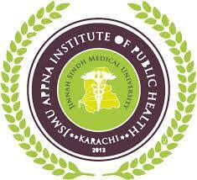
Theme: Universal Health Coverage; Everyone, Everywhere.
First Public Health Multidisciplinary Conference
April 6, 2019.
Organized by APPNA Institute of Public Health, Jinnah Sindh Medical University

Registration Form for Conference

Name in Capital letters: ____________________________________________
Category: Undergraduate Postgraduate Doctor
Designation: _______________________ Institute/Hospital: __________________________________
Country: _______________________________ State/City: ___________________________________
Email: ________________________________ Mobile: ______________________________________
Address: ____________________________________________________________________________

No Registration Fee

SUBMISSION METHOD:
- Registration should be submitted at aiph.conf2019@jsmu.edu.pk
- Registration would be done on First Come, First Served basis
- On spot registrations will also be entertained.

